Wireframe task



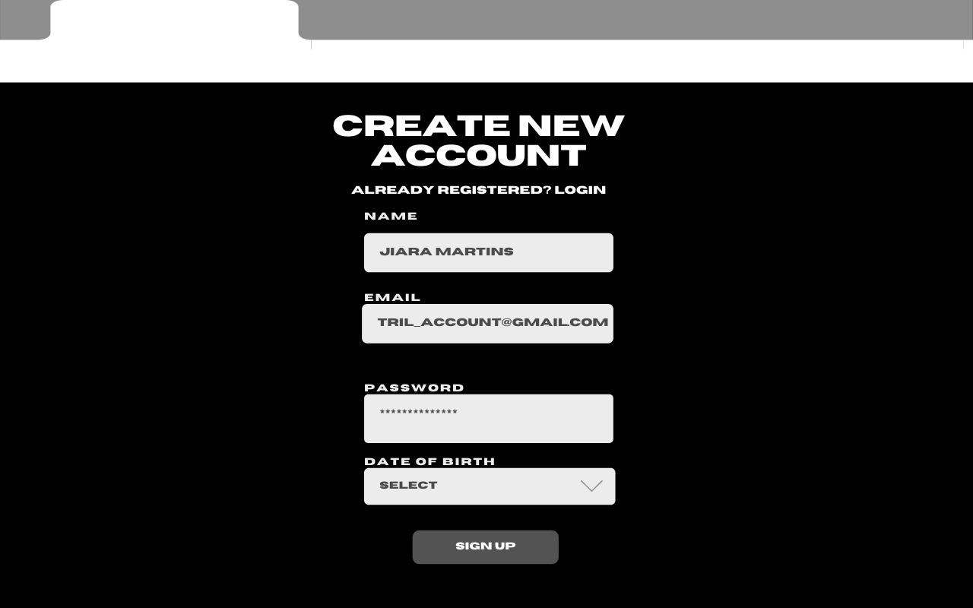

These are the first two basic pages of th website. This is different from my first idea of the math tuitions since I have changed the original idea 😅.